**AWS Hands-On Assignment 05 (On Console and CLI)**

**Network Interface + Hibernate Instance**

**QUESTION NO: 01**

**Console:**

**1. Create Network Interface (NIC) on Console:**  
   - Navigate to the AWS Management Console.  
   - Create a new Network Interface (NIC) in a specific VPC and subnet.  
   - Associate the NIC with a security group.  
   - Note down the Private IP address assigned to the NIC.

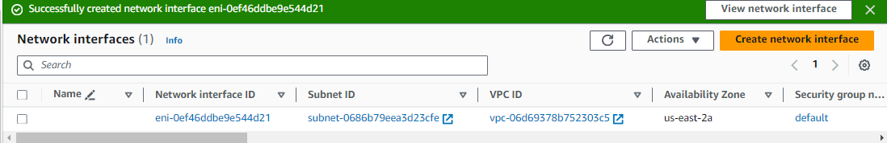

**2. Launch EC2 Instance and Associate NIC:**  
   - Launch a new EC2 instance using the AWS Management Console.  
   - During the instance launch, associate the previously created NIC with the instance.  
   - Confirm that the instance has the expected private IP address.

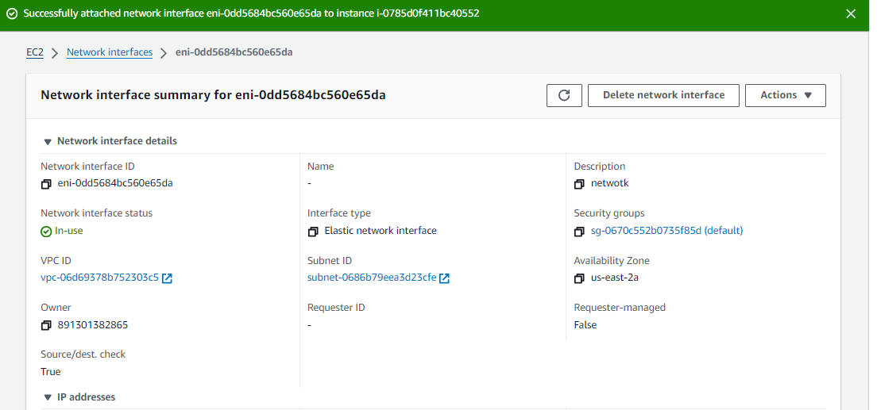

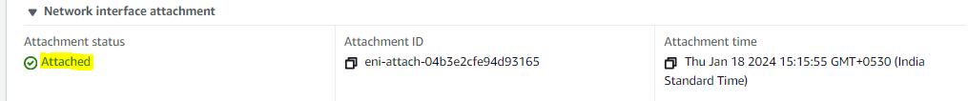



**3. Verify Network Interface Configuration:**  
   - Access the EC2 instance and verify the network interface configuration.  
   - Use the console to check the details of the associated NIC.

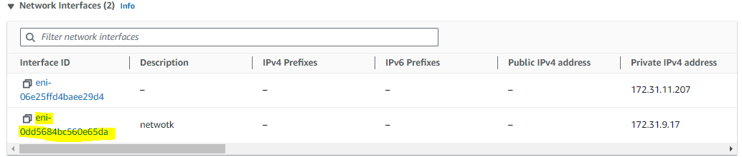

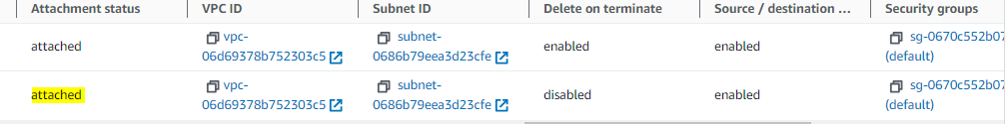

**QUESTION NO: 02**

**Hibernate Instance**

**1. Hibernate EC2 Instance on Console:**  
   - Launch a new EC2 instance using the AWS Management Console.  
   - Access the console to hibernate the running instance.  
   - Confirm the status change to "hibernating."

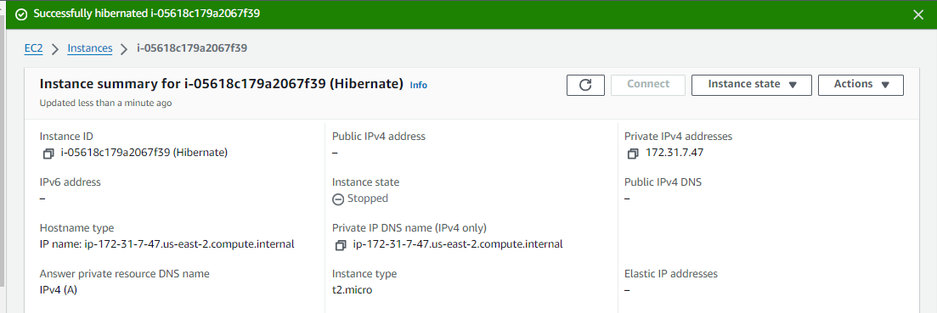

**2. Resume Hibernated EC2 Instance:**  
   - Resume the hibernated instance using the console.  
   - Confirm the instance state changes to "running."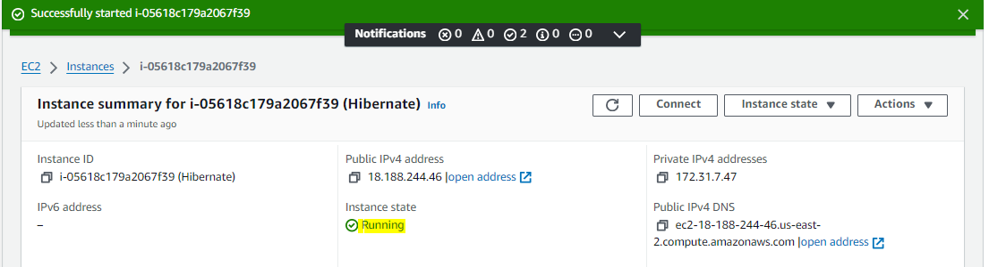

**3. Verify Instance State:**  
   - Check the instance state using the console to ensure successful hibernation and resumption.

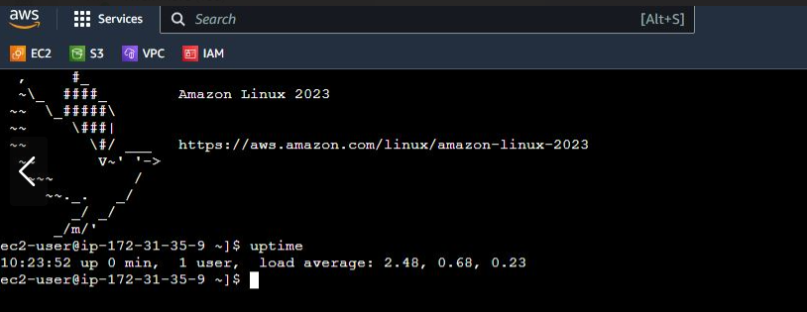

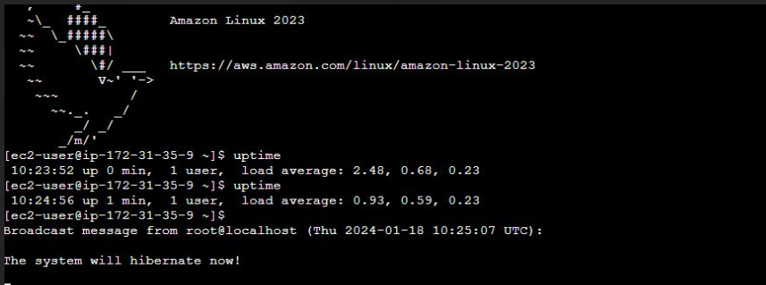

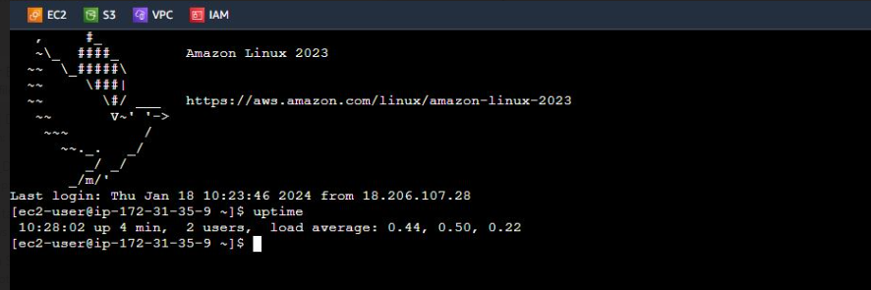

**CLI:**

**1. Create Network Interface (NIC) using AWS CLI:**  
   - Use the AWS CLI to create a new Network Interface (NIC) in a specific VPC and subnet.  
   - Associate the NIC with a security group.  
   - Note down the Private IP address assigned to the NIC.

root@DESKTOP-PDOJQQA:vivek# **aws ec2 create-network-interface --subnet-id subnet-0686b79eea3d23cfe --description "my network interface**

**" --groups sg-0670c552b0735f85d**

{

"NetworkInterface": {

"AvailabilityZone": "us-east-2a",

"Description": "my network interface",

"Groups": [

{

"GroupName": "default",

"GroupId": "**sg-0670c552b0735f85d**"

}

],

"InterfaceType": "interface",

"Ipv6Addresses": [],

"MacAddress": "02:8f:1a:cc:7c:17",

"NetworkInterfaceId": "eni-0cd04b4f25db70464",

"OwnerId": "891301382865",

"PrivateDnsName": "ip-172-31-2-192.us-east-2.compute.internal",

"PrivateIpAddress": "172.31.2.192",

"PrivateIpAddresses": [

{

"Primary": true,

"PrivateDnsName": "ip-172-31-2-192.us-east-2.compute.internal",

"PrivateIpAddress": "172.31.2.192"

}

],

"RequesterManaged": false,

"SourceDestCheck": true,

"Status": "pending",

"SubnetId": "subnet-0686b79eea3d23cfe",

"TagSet": [],

"VpcId": "vpc-06d69378b752303c5"

}

}

**2. Launch EC2 Instance and Associate NIC:**  
   - Launch a new EC2 instance using the AWS Management Console.  
   - During the instance launch, associate the previously created NIC with the instance.  
   - Confirm that the instance has the expected private IP address.

root@DESKTOP-PDOJQQA:vivek# **aws ec2 create-key-pair --key-name web_key --query 'KeyMaterial' --output text > web_key.pem**

root@DESKTOP-PDOJQQA:vivek# **aws ec2 run-instances --image-id ami-0cd3c7f72edd5b06d --key-name web_key --instance-type t2.micro --security-group-ids sg-0670c552b0735f85d --associate-public-ip-address --tag-specifications 'ResourceType=instance,Tags=[{Key=Name,Value=E**

**c2_Instance}]'**

root@DESKTOP-PDOJQQA:vivek# **aws ec2 attach-network-interface --network-interface-id eni-0cd04b4f25db70464 --instance-id i-09381a5c6ba266c89 --device-index 1**

{

"AttachmentId": "eni-attach-04883d76439c16425",

"NetworkCardIndex": 0

}

root@DESKTOP-PDOJQQA:vivek# **aws ec2 describe-network-interfaces --network-interface-ids eni-0cd04b4f25db70464**

{

"NetworkInterfaces": [

{

"Attachment": {

"AttachTime": "2024-01-18T11:19:54.000Z",

"AttachmentId": "eni-attach-04883d76439c16425",

"DeleteOnTermination": false,

"DeviceIndex": 1,

"NetworkCardIndex": 0,

"InstanceId": "i-09381a5c6ba266c89",

"InstanceOwnerId": "891301382865",

"Status": "attached"

},

"AvailabilityZone": "us-east-2a",

"Description": "my network interface",

"Groups": [

{

"GroupName": "default",

"GroupId": "sg-0670c552b0735f85d"

}

],

"InterfaceType": "interface",

"Ipv6Addresses": [],

"MacAddress": "02:8f:1a:cc:7c:17",

"NetworkInterfaceId": "eni-0cd04b4f25db70464",

"OwnerId": "891301382865",

"PrivateDnsName": "ip-172-31-2-192.us-east-2.compute.internal",

"PrivateIpAddress": "172.31.2.192",

"PrivateIpAddresses": [

{

"Primary": true,

"PrivateDnsName": "ip-172-31-2-192.us-east-2.compute.internal",

"PrivateIpAddress": "172.31.2.192"

}

],

"RequesterManaged": false,

"SourceDestCheck": true,

"Status": "in-use",

"SubnetId": "subnet-0686b79eea3d23cfe",

"TagSet": [],

"VpcId": "vpc-06d69378b752303c5"

}

]

}

**1. Hibernate EC2 Instance on Console:**  
   - Launch a new EC2 instance using the AWS Management Console.  
   - Access the console to hibernate the running instance.  
   - Confirm the status change to "hibernating."

root@DESKTOP-PDOJQQA:vivek# **aws ec2 run-instances --image-id ami-0cd3c7f72edd5b06d --instance-type t2.micro --key-name web_key --subnet-id subnet-0686b79eea3d23cfe --hibernation-options Configured=true --block-device-mappings '[{"DeviceName":"/dev/xvda","Ebs":{"VolumeSize":30,"VolumeType":"gp2","Encrypted":true}}]' --tag-specifications 'ResourceType=instance,Tags=[{Key=Name,Value=MY-HIBERNATE-INSTANCE}]'**

{

"Groups": [],

"Instances": [

{

"AmiLaunchIndex": 0,

"ImageId": "ami-0cd3c7f72edd5b06d",

"InstanceId": "i-0fa203030190a87d0",

"InstanceType": "t2.micro",

"KeyName": "web_key",

"LaunchTime": "2024-01-18T11:32:52.000Z",

"Monitoring": {

"State": "disabled"

},

"Placement": {

"AvailabilityZone": "us-east-2a",

"GroupName": "",

"Tenancy": "default"

},

"PrivateDnsName": "ip-172-31-14-225.us-east-2.compute.internal",

"PrivateIpAddress": "172.31.14.225",

"ProductCodes": [],

"PublicDnsName": "",

"State": {

"Code": 0,

"Name": "pending"

},

"StateTransitionReason": "",

"SubnetId": "subnet-0686b79eea3d23cfe",

"VpcId": "vpc-06d69378b752303c5",

"Architecture": "x86_64",

"BlockDeviceMappings": [],

"ClientToken": "b2a1178c-4abb-4604-87a3-5396740f3edb",

"EbsOptimized": false,

"EnaSupport": true,

"Hypervisor": "xen",

"NetworkInterfaces": [

{

"Attachment": {

"AttachTime": "2024-01-18T11:32:52.000Z",

"AttachmentId": "eni-attach-09a46b15c616b9336",

"DeleteOnTermination": true,

"DeviceIndex": 0,

"Status": "attaching",

"NetworkCardIndex": 0

},

"Description": "",

"Groups": [

{

"GroupName": "default",

"GroupId": "sg-0670c552b0735f85d"

}

],

"Ipv6Addresses": [],

"MacAddress": "02:7a:d3:3f:29:31",

"NetworkInterfaceId": "eni-0a4b0ea12e376c86e",

"OwnerId": "891301382865",

"PrivateDnsName": "ip-172-31-14-225.us-east-2.compute.internal",

"PrivateIpAddress": "172.31.14.225",

"PrivateIpAddresses": [

{

"Primary": true,

"PrivateDnsName": "ip-172-31-14-225.us-east-2.compute.internal",

"PrivateIpAddress": "172.31.14.225"

}

],

"SourceDestCheck": true,

"Status": "in-use",

"SubnetId": "subnet-0686b79eea3d23cfe",

"VpcId": "vpc-06d69378b752303c5",

"InterfaceType": "interface"

}

],

"RootDeviceName": "/dev/xvda",

"RootDeviceType": "ebs",

"SecurityGroups": [

{

"GroupName": "default",

"GroupId": "sg-0670c552b0735f85d"

}

],

"SourceDestCheck": true,

"StateReason": {

"Code": "pending",

"Message": "pending"

},

"Tags": [

{

"Key": "Name",

"Value": "MY-HIBERNATE-INSTANCE"

}

],

"VirtualizationType": "hvm",

"CpuOptions": {

"CoreCount": 1,

"ThreadsPerCore": 1

},

"CapacityReservationSpecification": {

"CapacityReservationPreference": "open"

},

"HibernationOptions": {

"Configured": true

},

"MetadataOptions": {

"State": "pending",

"HttpTokens": "required",

"HttpPutResponseHopLimit": 2,

"HttpEndpoint": "enabled",

"HttpProtocolIpv6": "disabled",

"InstanceMetadataTags": "disabled"

},

"EnclaveOptions": {

"Enabled": false

},

"BootMode": "uefi-preferred",

"PrivateDnsNameOptions": {

"HostnameType": "ip-name",

"EnableResourceNameDnsARecord": false,

"EnableResourceNameDnsAAAARecord": false

}

}

],

"OwnerId": "891301382865",

"ReservationId": "r-073294c154b6a7f99"

}

root@DESKTOP-PDOJQQA:vivek# **aws ec2 stop-instances --instance-ids i-0fa203030190a87d0 --hibernate**

{

"StoppingInstances": [

{

"CurrentState": {

"Code": 64,

"Name": **"stopping"**

},

"InstanceId": "i-0fa203030190a87d0",

"PreviousState": {

"Code": 16,

"Name": "running"

}

}

]

}

**2. Resume Hibernated EC2 Instance using AWS CLI:**  
   - Use the AWS CLI to resume the hibernated instance.  
   - Confirm the instance state changes to "running."

root@DESKTOP-PDOJQQA:vivek# **aws ec2 start-instances --instance-ids i-0fa203030190a87d0**

{

"StartingInstances": [

{

"CurrentState": {

"Code": 0,

"Name": "pending"

},

"InstanceId": "i-0fa203030190a87d0",

"PreviousState": {

"Code": 80,

"Name": "stopped"

}

}

]

}

**3. Verify Instance State using AWS CLI:**  
   - Use the AWS CLI to check the instance state and ensure successful hibernation and resumption.

root@DESKTOP-PDOJQQA:vivek# **aws ec2 describe-instances --instance-ids i-0fa203030190a87d0 --query 'Reservations[*].Instances[*].[InstanceId,State.Name]'**

[

[

[

"i-0fa203030190a87d0",

"running"